Thursday Bidding Tips 12 Board 7 played on 19/7/2018 Winter Individual
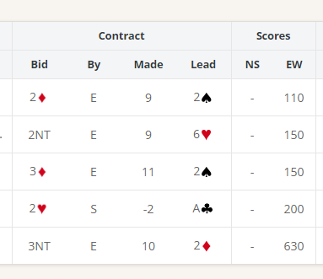
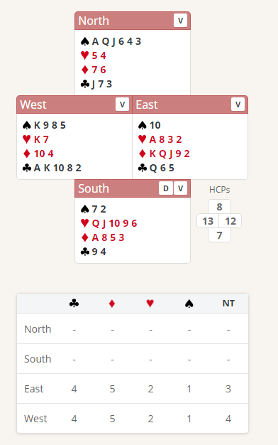

Suggested Bidding
N | E | S Dealer | W
 |  | Pass | 1C
1S | 2D | Pass | 3C
Pass | 3H | Pass | 3NT
Pass | Pass | Pass

- Wests Bid of 1 Club shows 12-19 Points and 4 clubs
- Norths overcall Bid of 1 Spade shows 8 plus points and a minimum 5 card suit with 2 honours
- Easts reply of 2 Diamonds shows 10 plus points and a 4 card suit. (New suit at the 2 level is a minimum of 10 points).
- South with 7 Points and 2 spades passes
- West rebids the clubs showing a 5 card suit
- East Bids 3 Hearts shows a 4 card suit (potential No Trump if West has a hold in spades)
- West with a hold in spades Bids 3 No Trumps

Suggested Lead from North 6 spades (4th of suit) West should win with the 10 in Dummy then lead small diamond

Further notes about Overcall bidding http://www.nzbridge.co.nz/user/inline/1768/NZB%20Beginner%2007%20-%20Student%20Notes.pdf

